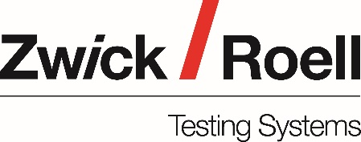

ZwickRoell Training Course:  Mechanical Testing Techniques for Metals | Date:  Wednesday, 28th September 2022  10:00hrs – 16:00hrs  Venue:  Jurys Inn,  Watling Street,  Hinckley,  Leicester  LE10 3JA

Delegate name/s:

Company/Organisation:

Company/Organisation address:

Contact telephone number:

Email address:

Purchase Order number: | Purchase Order value:

Accounts Department contact:

Accounts Department address:

- Please inform us if you have any special dietary requirements

- Please return completed form to: Darryl.Fern@zwickroell.com

