Mechanical Testing Techniques Training Course for Metals

Date: Thursday, 6th July 2023

Key learning objectives:

- Understand the meaning of terms such as strength, ductility, hardness, and toughness.

- Appreciate why compromise between high values of strength and toughness is necessary.

- Understand the metal structure differences that give rise to continuous and discontinuous yielding.

- Be familiar with parameters such as Young’s modulus (E), yield strength, proof stress, UTS, ductility measures, engineering stress-strain, true stress-true strain and work hardening index ‘n’

- Distinguish between ductile, brittle, and intergranular failures.

Section 1: Course introduction

Section 2: Tensile Tests

  - Tensile tests: parameters, sample preparation and types
  - Gripping methods: screw, wedge, hydraulic and pneumatic
  - Contact and non-contact extensometry
  - Continuous and discontinuous yielding; influence of metal structure
  - Further test parameters: engineering and true stress-strain, work hardening index

Section 3: Ductile, brittle, and intergranular failure

  - Deformation of ductile metals
  - Brittle (or cleavage) fracture
  - Ductile-brittle transition
  - Crack propagation and crack arresting mechanisms
  - Intergranular fracture

Section 4: Hardness Tests

  - Hardness principles: Brinell, Vickers, Rockwell; indenters and test conditions
  - Relationship between hardness and grain size: Hall-Petch equation
  - Micro-hardness tests: Vickers and Knoop
  - Nano-indentation
  - Hardness conversion

Section 5: Pendulum impact tests

  - Toughness: a definition
  - Charpy and Izod test procedures
  - Sample types: full and sub-sized samples
  - Test results: ductile-brittle transition temperature
  - Role of microstructure
  - Charpy vs Izod

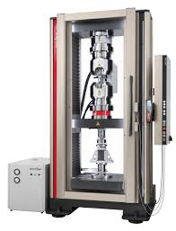

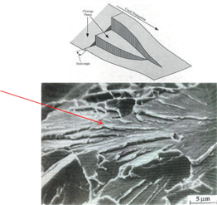

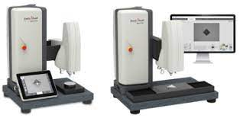

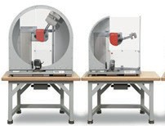

Section 6: Fatigue and creep testing

  - Fatigue in metals
  - Fatigue testing: axial loading and rotating bend test machines
  - Fatigue testing: stress-life (S-N), strain-life (ε-N) and fatigue crack growth rate (da / dN - ΔK) approaches
  - Stages of creep
  - Creep mechanisms: dislocation climb, Nabarro-Herring and Coble creep
  - Creep and stress rupture testing

Section 7: Fracture mechanics

  - Linear-elastic fracture theories
  - Fracture toughness tests: methods and sample types
  - Factors affecting toughness
  - Realm of application for different fracture mechanics theories; LEFM, EPFM etc.

Course fee:

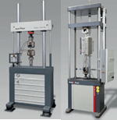

£250 + VAT per delegate which includes refreshments, lunch, course completion certificate & comprehensive training course manual.

Course venue:

ZwickRoell Ltd
Worcester Six Business Park
Clayfield Road
Worcester
WR4 0AD

Contact: alan.thomas@zwickroell.com

